End-of-year test
Vocabulary
Vocabulary
1 Look, read and write the letter.
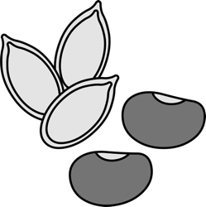 |  | 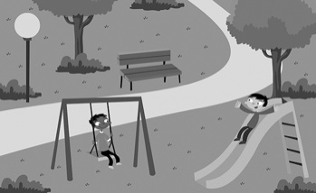 |  | 1 folder  2 chicken  3 zebra  4 watch  5 park  6 seeds
A | B | C
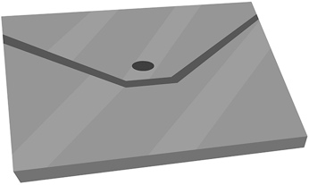 |  | 
D | E | F
/ 6
2 Look and tick ().
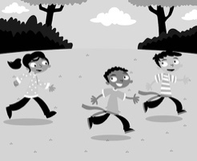 | 1 A ☐ play tag  B ☐ throw  C ☐ get dressed
 | 2 A ☐ castle  B ☐ vase  C ☐ peas
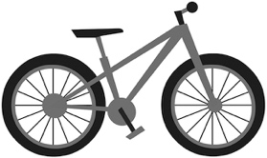 | 3 A ☐ nuts  B ☐ sandals  C ☐ bike
 | 4 A ☐ act  B ☐ juggle  C ☐ do judo
/ 4

Grammar
3 Read and tick ().
 | 1 What do hippos eat?  A ☐ They eat grass.  B ☐ They don’t eat grass.
 | 2 Has he got a dictionary?  A ☐ Yes, he has.  B ☐ No, he hasn’t.
 | 3 Do you have noodles for breakfast?  A ☐ Yes, I do.  B ☐ No, I don’t.
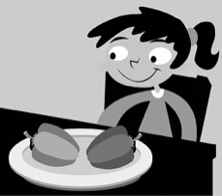 | 4 Does she like peppers?  A ☐ Yes, she does.  B ☐ No, she doesn’t.
/ 4
4 Look and write.
I do my homework I’m wearing it’s my the fork is longer there isn’t whose
 |  | 
1  trophy is it? | 2  a bracelet. | 3  puppet. It’s mine.
 | 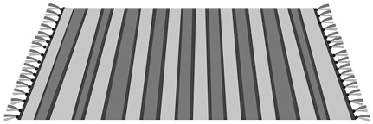 | 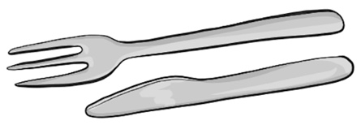
4  in the evening. | 5  a rug on the floor. | 6  than the knife.
/ 6
Reading
5 Read and circle Yes or No.
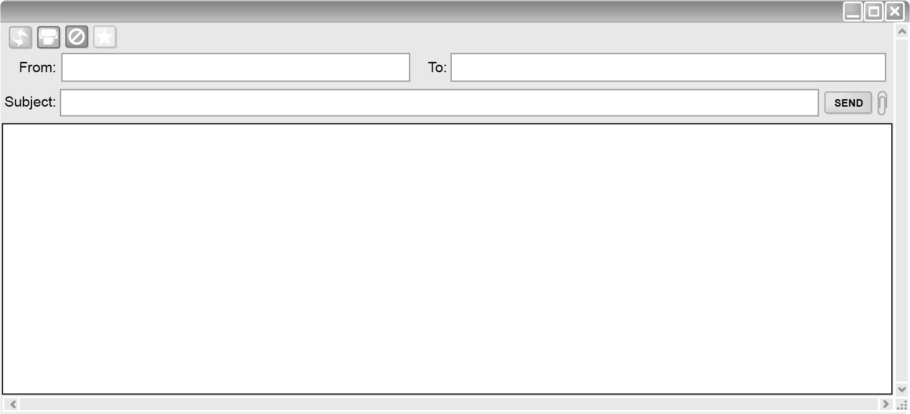
Carlos Diana
Hi from Carlos
Hello. I’m Carlos. I’ve got a big family and we’ve got a big, white house. I live in a beautiful town. There are lots of fun places in my town. My favourite place is the skate park. I go there with my friends, Jack and Lee, on Saturday. I rollerblade and skateboard there. I’m good at rollerblading and skateboarding! I don’t ride my bike at the skate park – I ride my bike in the park behind my school. There is a café next to the skate park. The café has got pizza!
There’s a man in the café. He’s got a guitar. I like listening to music … and eating pizza with my friends!

1 Carlos lives in a small house. Yes / No
2 Carlos goes to the skate park at the weekend. Yes / No
3 Carlos rides his bike at the skate park. Yes / No
4 There’s a café next to the park. Yes / No
5 Carlos likes pizza and music. Yes / No
/ 5
Writing
6 Read and complete.
brushes her but they happy because I do potatoes and
1 I like beans.
2 Do you like watching TV? Yes, .
3 I’m very it’s Friday!
4 Giraffes eat leaves, don’t eat meat.
5 In the morning, Lisa hair.
/ 5

Listening
7  14 Listen and circle T (true) or F (false).
 | 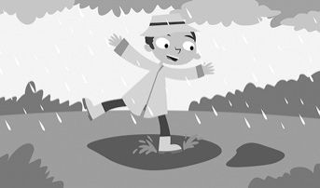 | 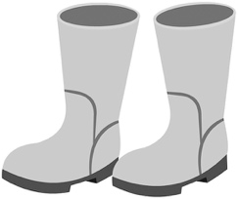
1 T / F | 2 T / F | 3 T / F
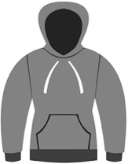 | 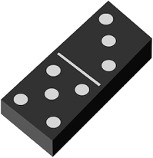
4 T / F | 5 T / F
/ 5
Speaking
8 Look, read and say.
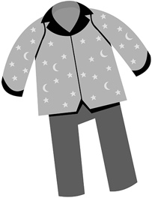 | 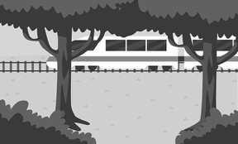 | 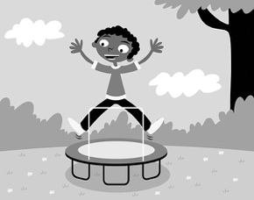 |  | 1 We’ve got our …  2 The train is …  3 I’m good at …  4 They live …  5 There are …
1 | 2 | 3
 | 
4 | 5
/ 5
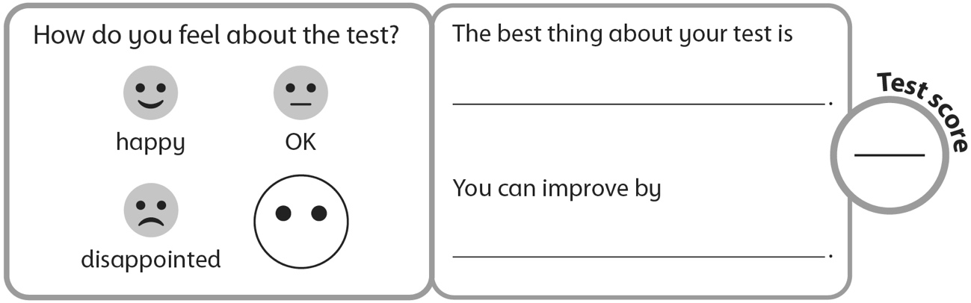
40

